Manual Test Plan

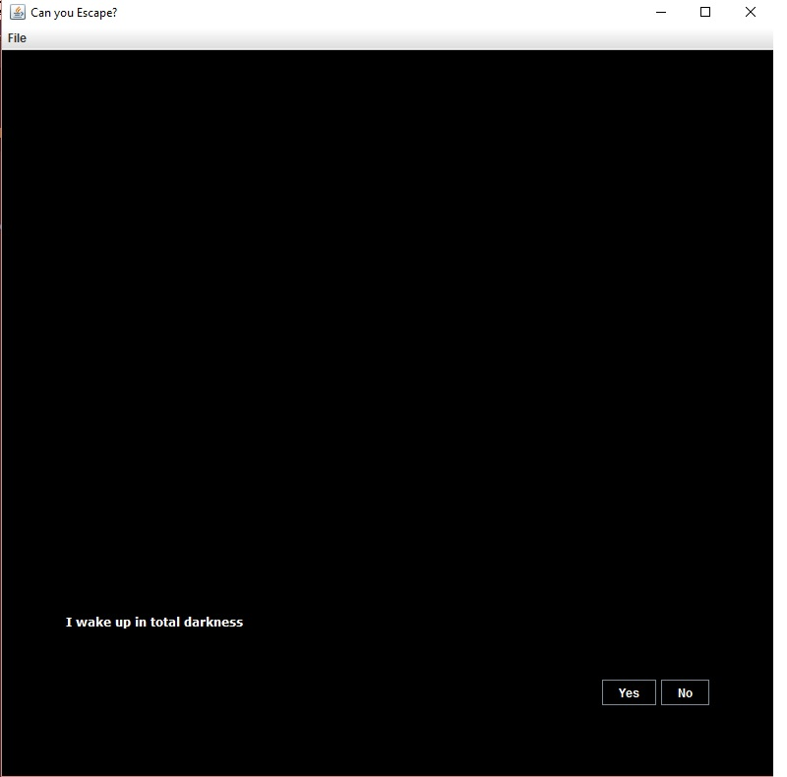

Beginning of the Game. Starts with text and YES or NO decision

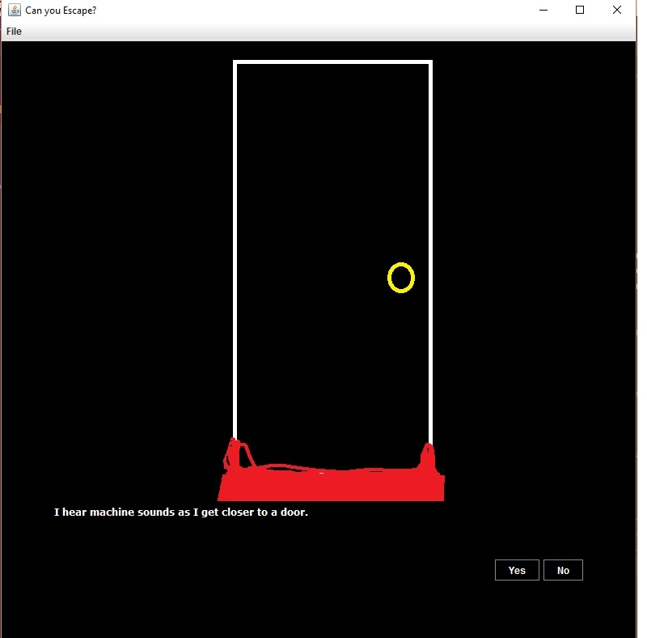

Pressing YES leads to the door

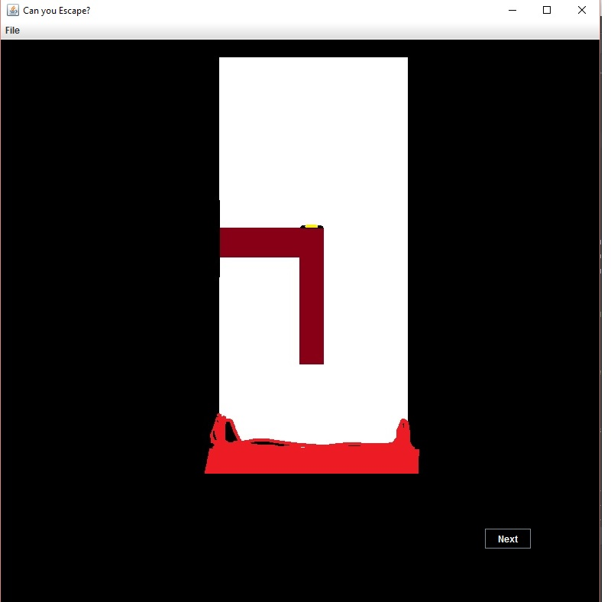

Pressing No leads to opening the door, having only a next button

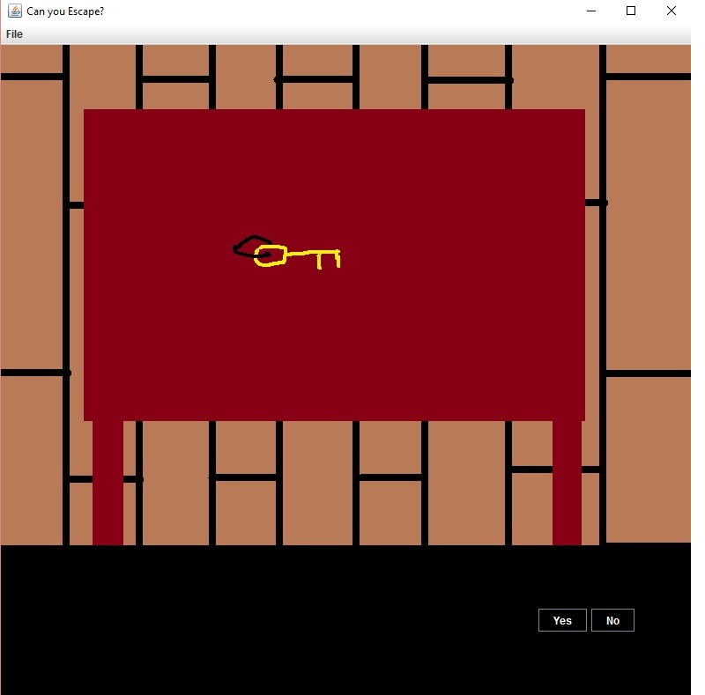

Decide whether to take to key or not.

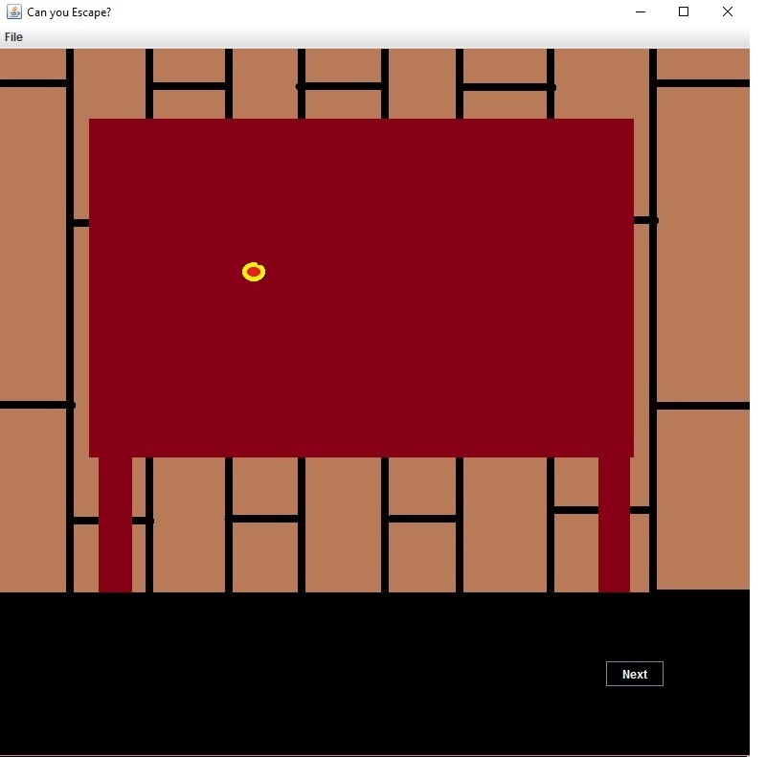

Taking the key triggers the trap. Thus ending the game.

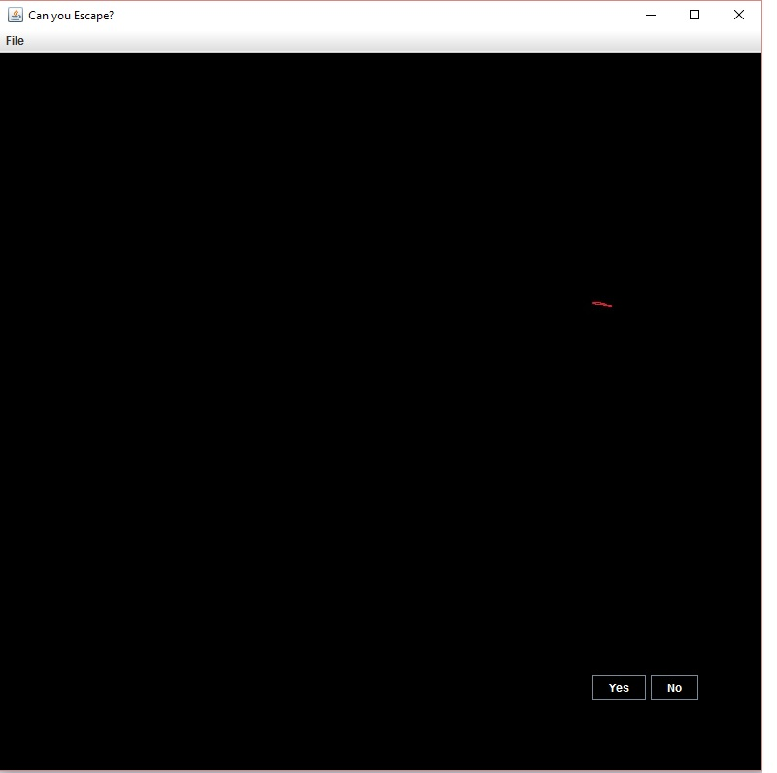

When selecting No, you think about what’s happening.

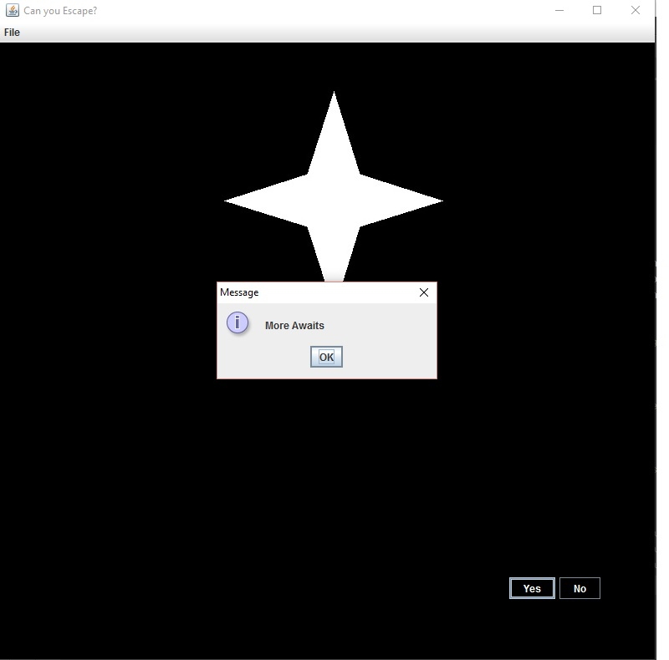

Find the light by putting the hand in the red hole